Meaning of life

This is a very big and tough question.

For past hundreds of centuries man has tried to find the meaning and purpose of life.

There are thousands of books lectures trying to explain meaning of life purpose of life.

Let look at who we are?

And compare ourselves with others on this planet.

From Big Bang theory to Darwinian theory of evolution we know we are product of evolution. We are at the top of chain?

-We are slaves of our senses. This is true, yes this is true.

- Most of our actions (other than to meet out basic needs (Maslow's Hierarchy of Needs).

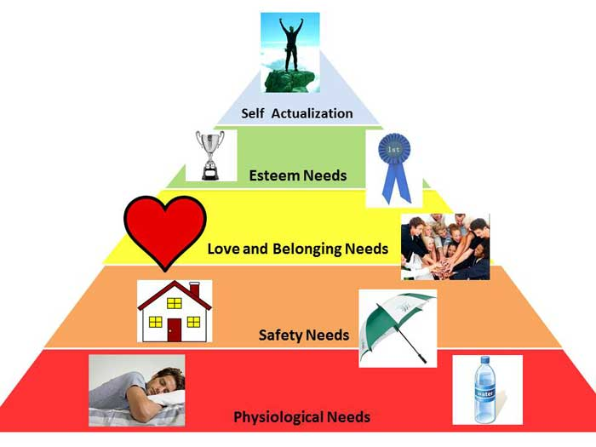 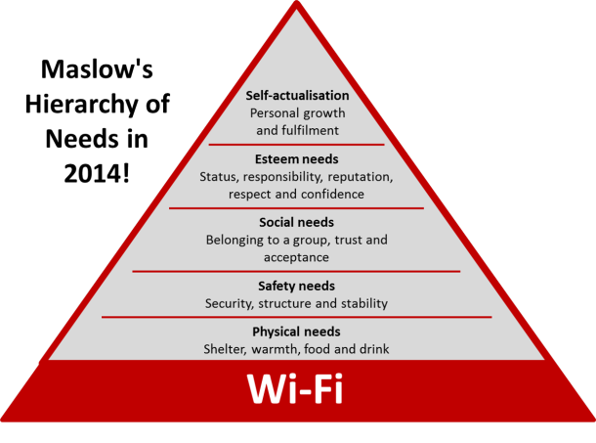

Our each action is to satisfy our hunger. Either what we are doing is part of the big game plan and there is no immediate results. ( That is what differentiate us from animals)

Remember a moment when you are in a state where all the needs are satisfied. When you are feeling safe, no fear, with your loved one and your mind silent(not thinking about tomorrow or past).

You remember a baby sleeping in mother's lap and smirking/a sly smile. They look like an angel.

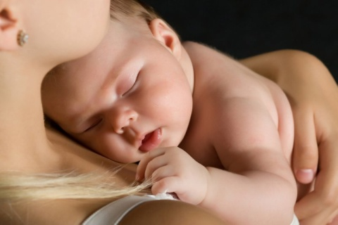

http://www.goodreads.com/quotes/tag/meaning-of-life